**Pravinyam Cloud Database**

**Exercise table:**

For Exercises, we have cexercises table in the PostgreSQL database

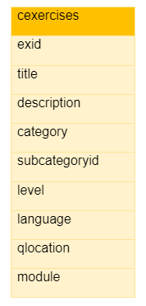

**Columns description:**

1. exid: It is a primary key for exercises and it contains unique values.
2. title: It is created by combining category, subcategoryid and level (i.e. Basics-Operators-2)
3. description: It describes the exercise for the given topic
4. category: It describes the topic name for the given programming language (For example C programming contains Basics, Decision Control, Loop Control, Arrays, Strings, etc.)
5. subcategoryid: It is a subcategory for the given category
   1. (i.e. For the Basics category we have Operators, Type of Variables, Type Conversion, etc.)
6. level: It defines the difficulty level of the program (1 -10)
7. language: It describes the different programming languages like C, Python, R, Javascript, etc.
8. qlocation: It is the location of code files that are stored in the cloud
9. module: All the codes are segregated according to the modules (i.e. reader, debug, and solver)

**Create Query for cexercises table**

CREATE TABLE IF NOT EXISTS public.cexercises

(

exid character varying(100) COLLATE pg_catalog."default" NOT NULL,

title character varying(100) COLLATE pg_catalog."default",

description character varying(250) COLLATE pg_catalog."default",

category character varying(100) COLLATE pg_catalog."default",

subcategoryid character varying(100) COLLATE pg_catalog."default",

level bigint,

language character varying(100) COLLATE pg_catalog."default",

qlocation character varying(100) COLLATE pg_catalog."default",

module character varying(100) COLLATE pg_catalog."default",

CONSTRAINT cexercises_pkey PRIMARY KEY (exid)

)

The id is created according to the category and subcategories, you can refer the below diagram to understand each unique id

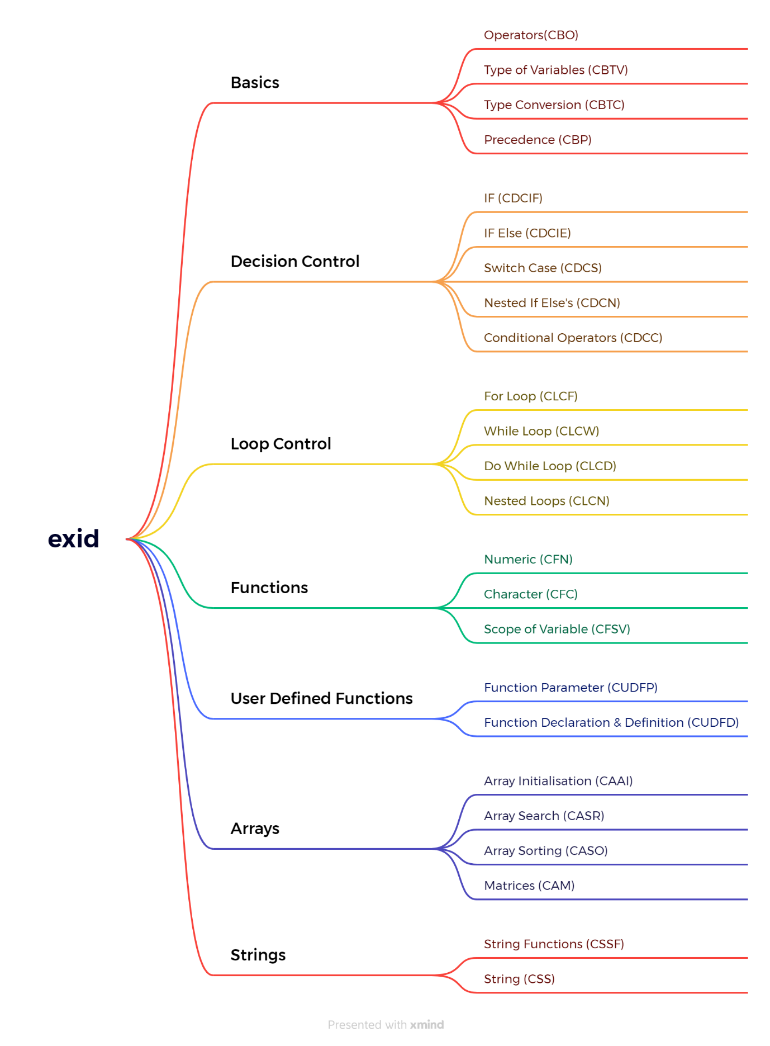

**Q&A table:**

Each Exercises have question for that you have to refer cqadata table which consists of six columns in postgresql database.

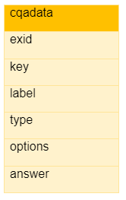

**Columns description:**

1. exid: It describe exercise id
2. key: It describe question id for each exercise
3. label: It describe the questions for the exercise
4. type: It describes the answer type (For example like number, text, radio or checkbox, etc.)
5. options: If answer type is radio/checkbox then for that you require options
6. answer: It describes the answer for the given question

**Create Query for cqadata table**

CREATE TABLE IF NOT EXISTS public.cqadata

(

exid character varying(100) COLLATE pg_catalog."default" NOT NULL,

key bigint NOT NULL,

label character varying(500) COLLATE pg_catalog."default",

type character varying(250) COLLATE pg_catalog."default",

options character varying(250) COLLATE pg_catalog."default",

answer character varying(250) COLLATE pg_catalog."default"

)

**Module Master Table:**

For module, we have a modulemaster table in the PostgreSQL database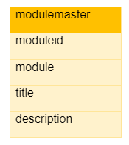

**Columns description:**

1. moduleid: describe id for modules
2. module: Describes 3 modules like reader, debug & solver
3. title: Describe each module with appropriate title
4. description: Describe each module in brief

**Create Query for modulemaster table**

CREATE TABLE IF NOT EXISTS public.modulemaster

(

moduleid bigint,

module character varying(100) COLLATE pg_catalog."default",

title character varying(500) COLLATE pg_catalog."default",

description character varying(250) COLLATE pg_catalog."default"

)

**Category Table:**

For Locking and unlocking features we have a category table that makes us understand which category/subcategory should be kept locked and unlocked for users.

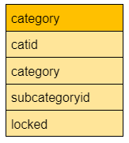

**Columns description:**

1. catid: Describe id’s for each category and subcategories.
2. category: Describes category for the given exercise
3. subcategoryid: Describe subcategories for category
4. locked: Describe locking and unlocking features for each category and it is 0 when that category/subcategories is unlocked and it is 1, 2,3 for locked which describes acc

**Create Query for category table**

CREATE TABLE IF NOT EXISTS public.category

(

catid character varying(100) COLLATE pg_catalog."default" NOT NULL,

category character varying(500) COLLATE pg_catalog."default",

subcategoryid character varying(250) COLLATE pg_catalog."default",

locked bigint,

CONSTRAINT my_catid_pkey PRIMARY KEY (catid)

)

Tables that need to be added

1. usergroup master
2. usermaster table
3. session table